# Problem 1:

## Part 1 (TestCaseStack.cpp):

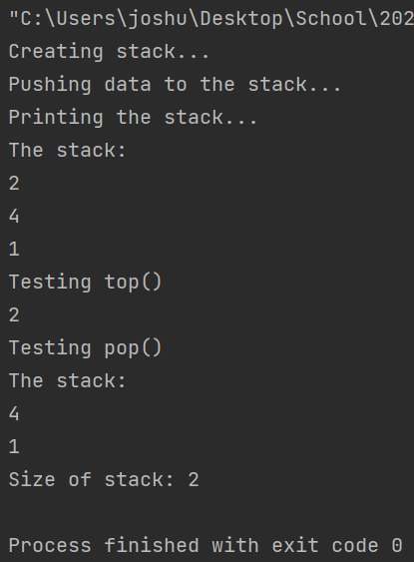

## Part 2 (TestCaseQueue.cpp):

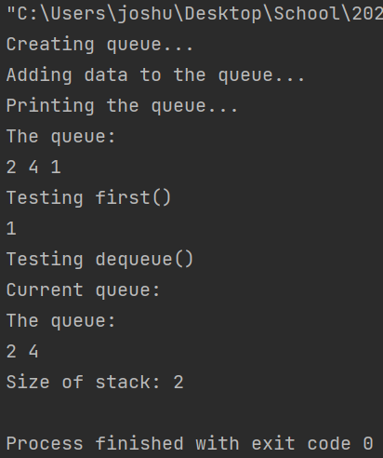

# Problem 2:

## Part 1 (CountTheOnes.cpp):

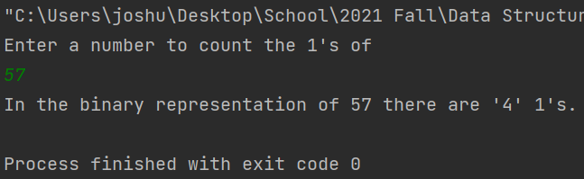

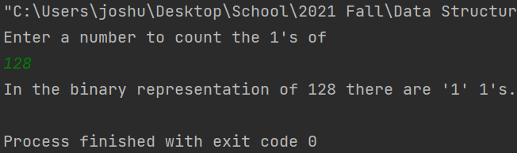

## Part 2 (RecursiveVectorSearch.cpp):

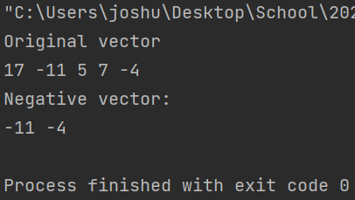

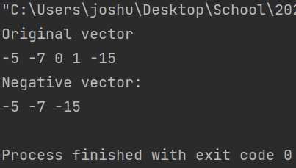

## Part 3 (UpDownRecursion.cpp):

